

**DOCUMENTATION FINAL PROJECT**

**TDM2123: Publishing on the world wide web**

|  |
| --- |
| *AMIGO HIJAB* |

|  |  |  |
| --- | --- | --- |
| **Student’s Name / ID** | **:** | 1) Nur Amirah Syazwan Binti Abdul Aziz / IPJ200310366 |
|  |  | 2) Nur Ayuni Fadya Binti Foat / IPJ200310326 |
| **Class** | **:** | DMM0304 |
| **Lecturer’s Name** | **:** | Encik Muhammad Syafiq Bin Haron |
| **Date of submission** | **:** | 18 JUNE 2021 |

**TABLE OF CONTENT**

|  |  |  |  |
| --- | --- | --- | --- |
| **NO.** | **CONTENT** | | **PAGES** |
|  |  | |  |
|  |  | |  |
| **1.0** | **Introduction** | | **1** |
|  |  | |  |
|  |  | |  |
| **2.0** | **Project Profile** | | **2** |
|  |  |  |  |
|  |  |  |  |
| **3.0** | **Purpose Statement** | | **3** |
|  |  |  |  |
|  |  |  |  |
| **4.0** | **Ideation**  **4.1 Mind Map**  **4.2 Primary Navigation** | | **4 - 5** |
|  |  |  |  |
|  |  |  |  |
| **5.0** | **Navigation Structure** | | **6** |
|  |  |  |  |
|  |  |  |  |
| **6.0** | **Target Audience** | | **7** |
|  |  | |  |
| **7.0** | **Storyboard** | | **8 - 10** |
|  |  | |  |
|  |  | |  |
| **8.0** | **Conclusion** | | **11** |
|  |  | |  |
|  |  |  |  |
|  |  |  |  |

|  |
| --- |
| 1. **: INTRODUCTION**   After discussion and meetings, we decided to choose fashion as our website topics because it has and I would like to hijab fashion skill and we want to explore our with others my experiences. |

|  |
| --- |
| 1. **: PROJECT PROFILE**   we have discussed to choose fashions for the title of our websites and the fashions we want to show are hijab fashions.  We divide the tasks for our group members as follows, the task for Nur Amirah Syazwan Binti Abdul Aziz is to be thorough, find resources (pictures, information), (hijab care) Website (Contact Page) Documentation (Mind map, main navigation, Storyboard) . For the job of Nur Ayuni Fadya Binti Mohd Foat is Website (Main Page, Gallery Page), (hijab tutorial) Documentation (Mind map, Introduction, Information, conclusion), Presentation slides |

|  |
| --- |
| 1. **: PURPOSE STATEMENT**   **Goal**  **PRIMARY**   * To show different types of hijab fashions   **SECONDARY**   * Share how to wear hijab fashion with toturials   **OBJECTIVES**   * include information and images * include videos toturial * giving tips on how to care and wear hijab |

|  |
| --- |
| 1. **: IDEATION**    1. **Mind Map**    2. **Primary Navigation** |

|  |
| --- |
| 1. **: NAVIGATION STRUCTURE** |

PROVIDE GUIDANCE ON HOW TO CARE FOR THE LIDS

PICTURE

TYPE OF HIJAB

SHOWS ANOTHER STYLE OF HOW TO WEAR A HIJAB IN THE PRESENCE OF A TOTURIAL VIDEO

VIDEO TOTURIAL

NUMBER PHONE AND SOCIAL MEDIA

FIND US

HIJAB CARE

HOME

|  |
| --- |
| **6.0 : TARGET AUDIENCE** |

PSYCOGRAPHIC

* Love about hijab fashions
* Love to diversify the fashion of the hijab

DEMOGRAPHIC

* FEMALE
* AGE 10-65 YEARS OLD

**7.0 WEBSITE CONTENT**

Text, Image and Video content

|  |  |  |  |
| --- | --- | --- | --- |
| **#** | **File Name** | **Page** | **Content :** |
| 1. | Home.html | Home | Text :   * Navigation button   ( HOME , HIJAB CARE , TYPE OF HIJAB , TOTURIAL , FIND US )   * About us   -This website, created by two companions which is Nur Amirah Syazwan Binti Abdul Aziz and Nur Ayuni Fadya Binti Mohd Foat , We are students of KPTM IPOH, PERAK . For these websites we chose fashion as the title of our final project, the fashion we show is hijab fashion. In these websites, not only the various types of hijab fashions that we show but also hijab care tips, and videos. We hope with this partnership we can give everyone a try on different types of hijab fashions.  -This hijab care we share some tips for good hijab care so that the hijab is not easily or quickly damaged.  -This Type of Hijab we show some types of hijab that people often wear  -On this toturial shows some ways to wear a hijab with various fashion styles  -for anyone who wants to ask us any questions, please go to the social media site, email and phone number for questions  Image : |

|  |  |  |  |
| --- | --- | --- | --- |
| **#** | **File Name** | **Page** | **Content :** |
| 2. | Care.html | Hija Care Page | Text :   * Navigation button   ( HOME , HIJAB CARE , TYPE OF HIJAB , TOTURIAL , FIND US )   * Link Tips for Hijab Care <https://productiveandpositive.com/practical-tips-for-hijab-care/>   Image :   * Gallery slide |

|  |  |  |  |
| --- | --- | --- | --- |
| **#** | **File Name** | **Page** | **Content :** |
| 3. | Types.html | Type of hijab page | Text :   * Navigation button   ( HOME , HIJAB CARE , TYPE OF HIJAB , TOTURIAL , FIND US )  Image :   * Gallery slide |

|  |  |  |  |
| --- | --- | --- | --- |
| **#** | **File Name** | **Page** | **Content :** |
| 4. | Video.html | Video tutorial hijab pages | Text :   * Navigation button   ( HOME,HIJAB CARE,TYPE OF HIJAB,TOTURIAL,FIND US )  Image :    Video : ( Youtube )   * <https://youtu.be/0c-5iEUNIDw> * <https://youtu.be/GMdqtt6OSCk> * <https://youtu.be/hOQgI354k3E> * <https://youtu.be/VjQP7es5Wgw> |

|  |  |  |  |
| --- | --- | --- | --- |
| **#** | **File Name** | **Page** | **Content :** |
| 5. | Find.html | Find us page | Text :   * Navigation button   ( HOME,HIJAB CARE,TYPE OF HIJAB,TOTURIAL,FIND US )   * Contact Amigo Hijab * Phone Number : 01123501758 * * Email : amigohijab@gmail.com * * Instagram : AMIGOHIJAB * * Twitter : AMIGOHIJAB *   Image :   * Gallery slide |

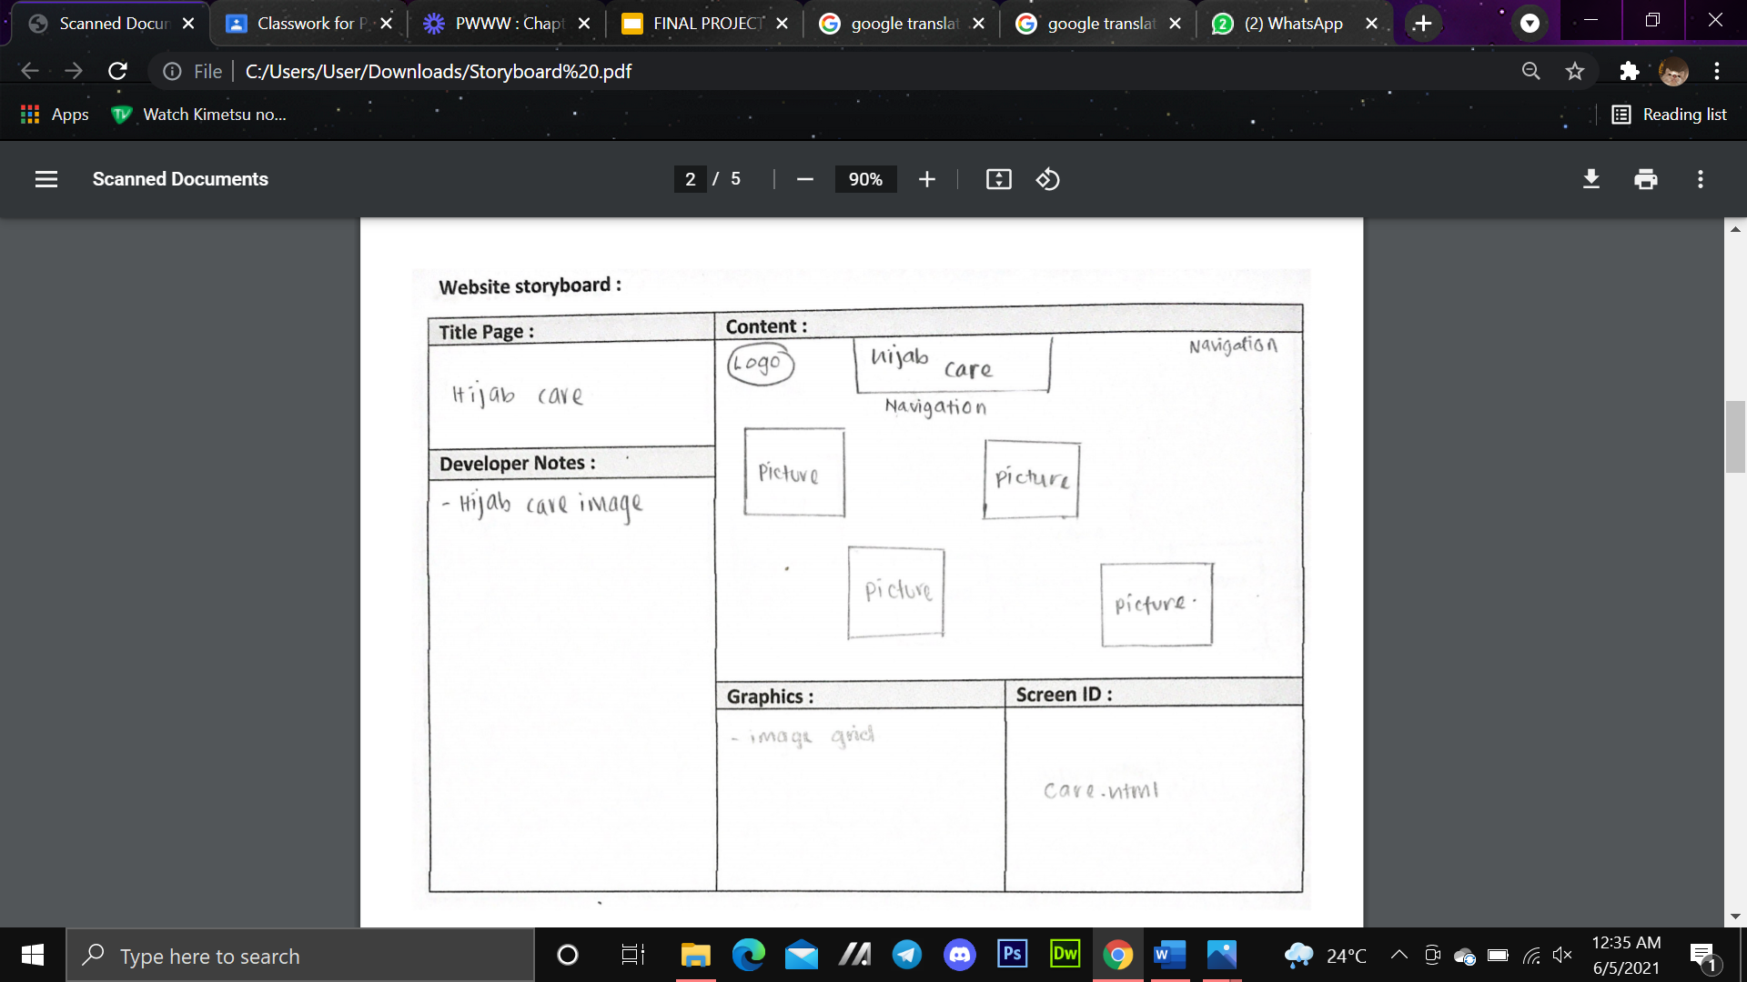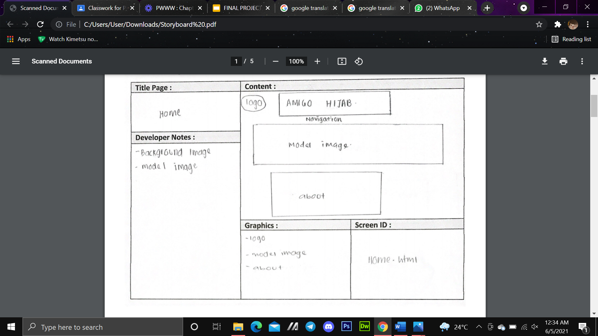

|  |
| --- |
| **7.0 : STORYBOARD** |

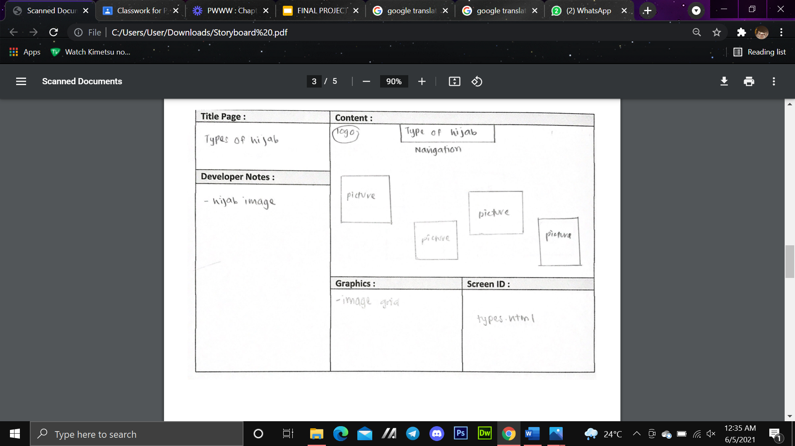

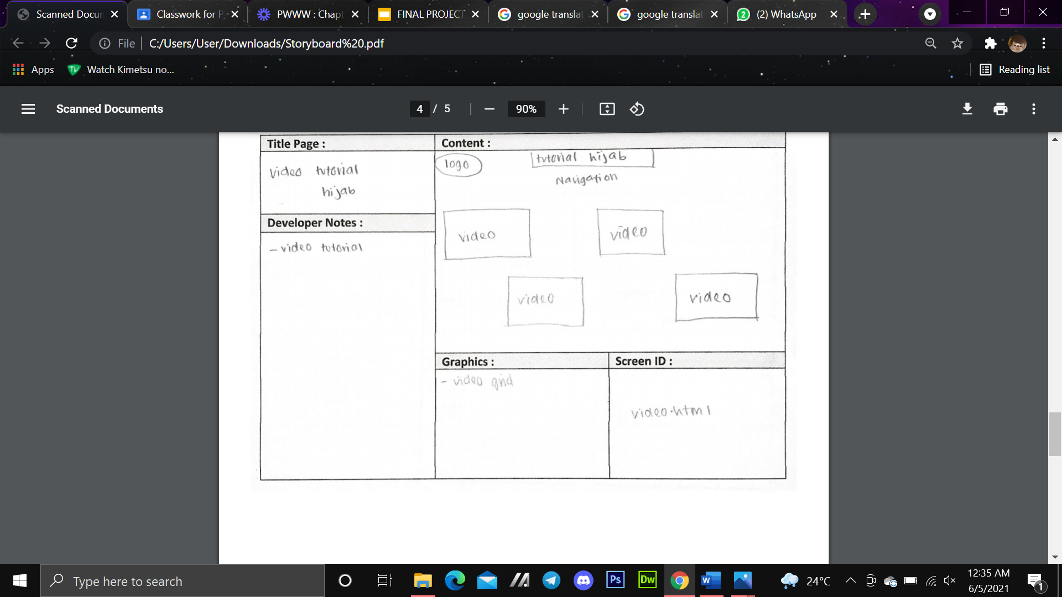

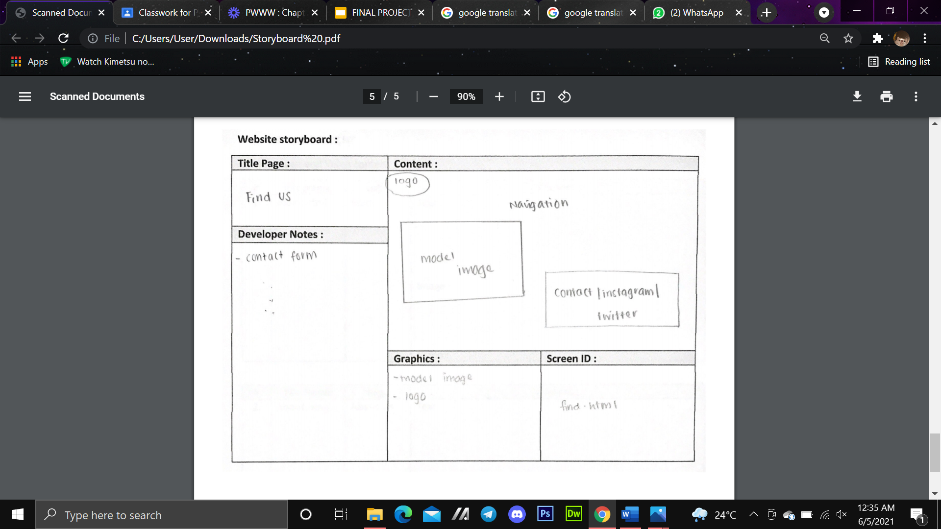

|  |
| --- |
| **8.0 : CONCLUSION** |

Based on our project , the conclusions is website hijab fashion can helps everyone know more information and how to care and wear with various styles of lids on a website . We also can get more friends and learn the same interest with us.

We also have a good time together when doing this website . Besides about hijab fashion , we also learned to doing this final project together as a team .